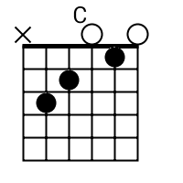
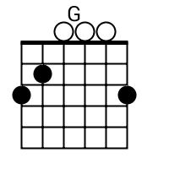
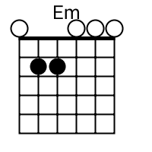
Lost Boy
Ruth B

||: E^{m} | G | C | G :||

There was a time, when I was alone. Nowhere to go and no place to call home.
My only friend was the man in the moon
and even sometimes he would go away too
Then one night as I close my eyes I saw a shadow flying high.

He came to me with the sweetest smile, told me he wanted to talk for awhile.
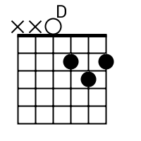
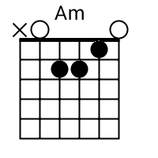
He said, “Peter Pan that's what they call me.I promise that you'll never be lonely.”
A^{m} D
And ever since that day

||: E^{m} | G | C | G :||
I am a lost boy from Neverland.Usually hanging out with Peter Pan
And when we're bored we play in the woods,
Always on the run from Captain Hook.
“Run, run, lost boy,” they say to me; away from all of reality.
||: Neverland is home to lost boys like me
And lost boys like me are free. :||

He sprinkled me in pixie dust and told me to believe
Believe in him, and believe in me. Together we will fly away in a cloud of green
To your beautiful destiny. As we soared above the town that never loved me.
I realized I finally had a family. Soon enough we reached Neverland.
A^{m} D
Peacefully my feet hit the sand and ever since that day.

Chorus, Bridge:

||: Peter Pan, Tinkerbell, Wendy Darling,
even Captain Hook, you are my perfect storybook
Neverland I love you so, you are now my home sweet home.
Forever a lost boy at last. :||
A^{m} D
And for always I will sing

Chorus, Outro

||: Neverland is home to lost boys like me and lost boys like me are free. :||

