Corks Away! Name: ____________________ Date: ________
Take a cork or piece of Styrofoam and modify it so that it sinks. Bonus points if you can make something neutrally buoyant. You cannot destroy the cork – it needs to be reusable when you are done.
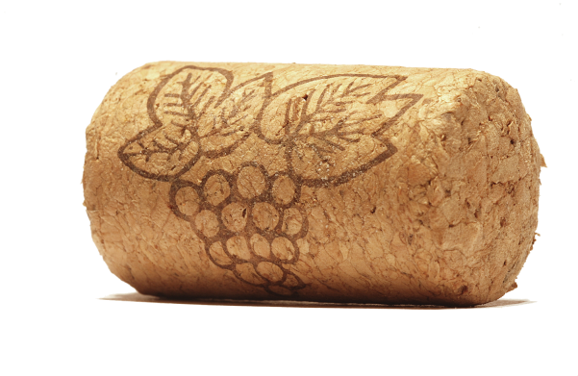
Draw your design.

