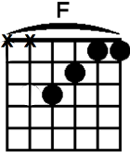
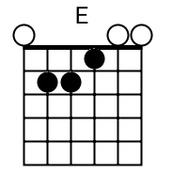
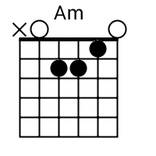
Believer Imagine Dragons

||: A^{m} | F | E :||

First things first, I'ma say all the words inside my head
I'm fired up and tired of the way that things have been, oh-ooh
The way that things have been, oh-ooh-ooh
Second thing second, don't you tell me what you think that I can be
I'm the one at the sail, I'm the master of my sea, oh-ooh
The master of my sea, oh-ooh-ooh

I was broken from a young age, taking my sulking to the masses
Write down my poems for the few, that looked at me,
took to me, shook to me, feeling me
Singing from heartache, from the pain, take up my message from the veins
Speaking my lesson from the brain, seeing the beauty through the...

A^{m} F E A^{m}
Pain! You made me a, you made me a believer, believer. Pain
F E A^{m}
You break me down, you build me up, believer, believer. Pain!
F
Oh, let the bullets fly, oh, let them rain
E/G# N.C. A^{m}
My life, my love, my drive, they came from... Pain!
F E
You made me a, you made me a believer, believer

Third things third, send a prayer to the ones up above
All the hate that you've heard has turned your spirit to a dove, oh-ooh
Your spirit up above, oh-ooh-ooh

I was choking in the crowd, building my rain up in the cloud
Falling like ashes to the ground, hoping my feelings, they would drown
But they never did, ever lived, ebbing and flowing, inhibited, limited
Till it broke open and rained down, it rained down, like... Chorus

Last things last, by the grace of the fire and the flames
You're the face of the future, the blood in my veins, oh-ooh
The blood in my veins, oh-ooh-ooh
But they never did, ever lived, ebbing and flowing, inhibited, limited
Till it broke open and rained down, it rained down, like... Chorus
||: A^{m} | F | E :||

